
Dates for Saturday Express
February 8, 2025
April 5, 2025
June 7, 2024

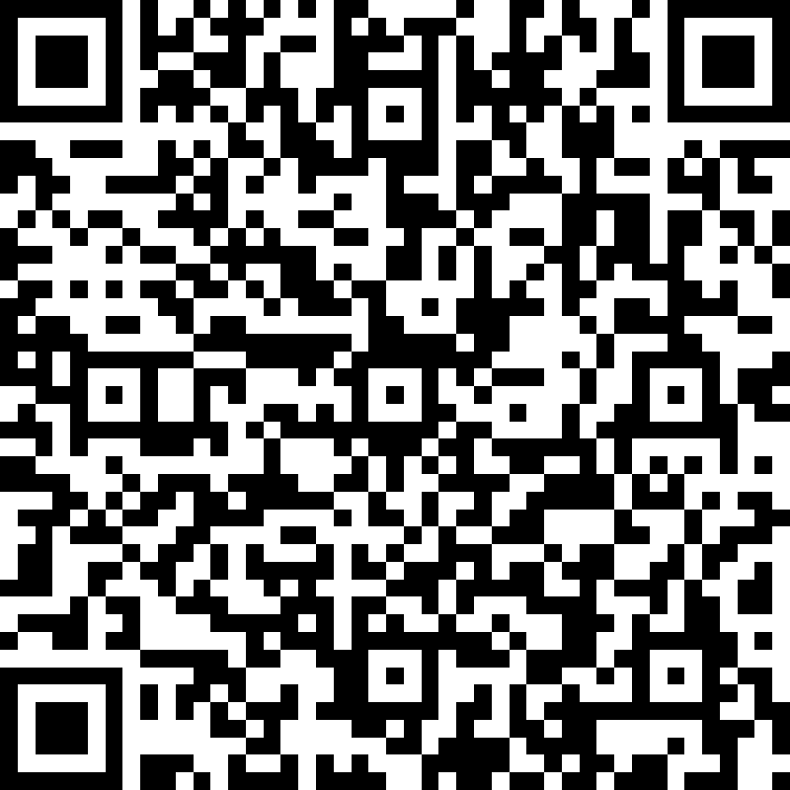

Dates for Breastfeeding Class
March 4, 2025
May 6, 2025
July 1, 2025

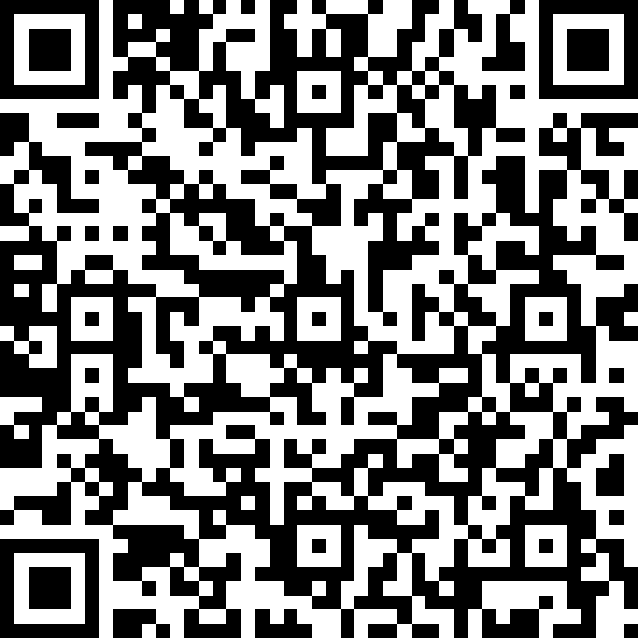

Contact our Lactation
Consultant, Kim Cruser via phone
443-245-7305 or by email at Kimberly.Cruser@ChristianaCare.org
All classes held at:
ChristianaCare, Union Hospital
Meeting Room 1 & 2
106 Bow St
Elkton, MD 21921

Family Education at ChristianaCare, Union Hospital
We are so excited to announce the return of our educational programming for parents! Please join us for our Childbirth Education Classes offered by the Family Education Department.

- Occurs every other month.
- ‘Saturday Express’ (covers prenatal, newborn care, Labor and Delivery)
- Breastfeeding Class
- Classes are free with registration.
- Classes are limited to 10 partners.
- Classes are taught in English, you are welcome to bring a translator

Scan the QR code to register

